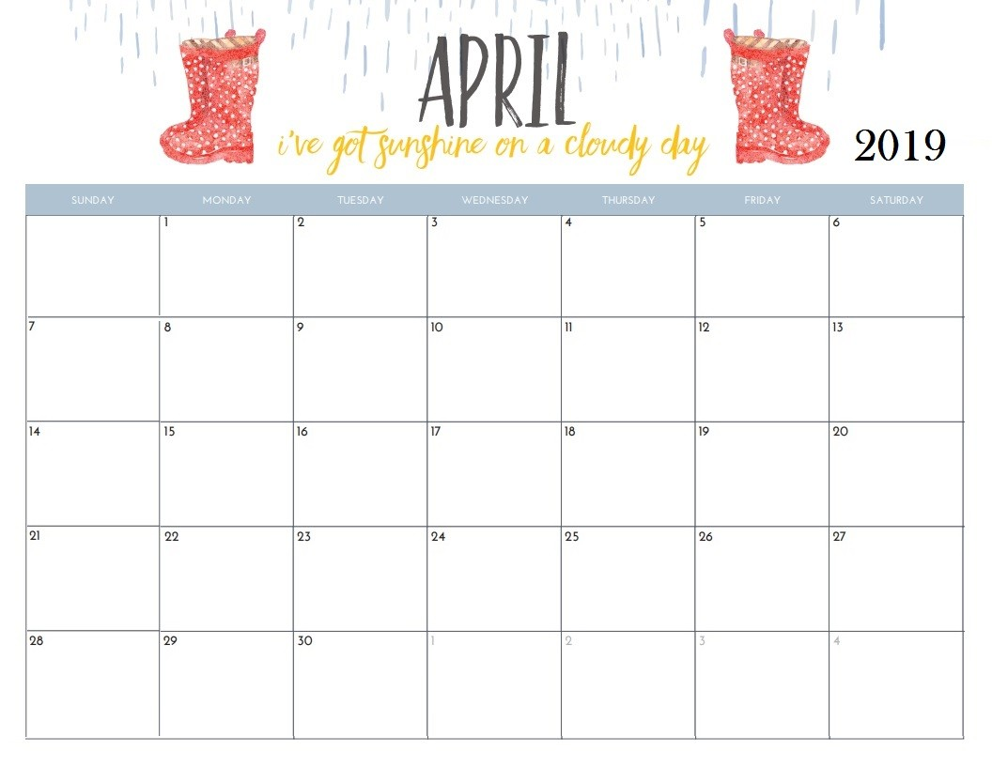

Ducks Unlimited $4.00

**Easter Science Experiment**

Dying Easter Eggs

FRENCH CLASS

EASTER PARTY

LITTLE LEAPERS

LITTLE LEAPERS

FRENCH CLASS

FRENCH CLASS

Walk Around UNB

Letter of the week

X /Little Leapers

Working on numbers 1-5

Working on numbers 6-10

Letter of the week

Z

Letter of the week

Y

**Happy Birthday Malak April.4th**

**Tobias April.4th and Jacob April.17th**

Forestry Complex

Easter Monday PSC is Closed

Good Friday PSC is closed

April Fools

Day