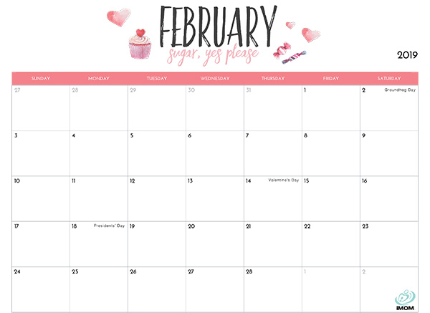

DRIVE IN MOVIE

FRENCH CLASS

KESWICK FIRE STATION

PJ DAY

FRENCH CLASS

MAKE A CAR

CLOSED FAMILY DAY

JAMES BDAY

PJ DAY

SLEIGH RIDE

$7.00

KENZIE BDAY

VALENTINE DAY!

FRENCH CLASS

OLIVE BDAY

PJ DAY!

TELL ME WHO YOU LOVE CRAFT

O’DELL

PARK

9:50-11:10

CHINESE

NEW YEAR!

PJ DAY!