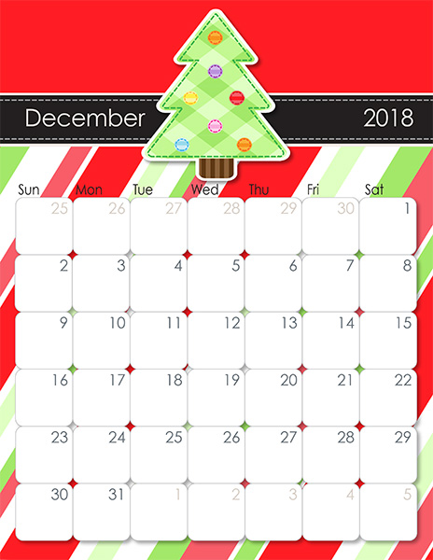

**PSC CLOSED  
HAPPY NEW YEARS!**

**PSC CLOSING AT 1:00PM**

**PSC CLOSED**

**PSC CLOSED  
Merry Christmas!**

**PSC CLOSED**

PJ Day!  
&  
Santa is visiting our class!

**Christmas Open House!  
3:00-4:00pm**

PJ Day!  
&   
Candy Cane Craft

Visiting Santa @ Regent Mall   
**9-11:30**

Bring a favorite Christmas book to share

Stocking Craft

Elf Craft

Xmas Soc Hop With the 2’s!

Bring in your favorite Christmas CD

Baking Ginger Breadman Cookies & Craft

PJ Day!  
&  
Christmas Light Craft

Santa calendar Craft